CA- 1

INTM517 – Business Analytics

Name - Nowneesh T

Section - Q3E45

Roll No – RQ3E45A08

Question:

Q1. Automotive industry is one of the largest and highly competitive economic sectors in the world. Due to the high competition, automotive companies are moving toward using social media sites to reach further customers and advertise their products in considerably short time.

Twitter is one of the highest growing social media websites in the world. Analyse the sentiment of customers of these two companies with the help of 500 tweets downloaded from each company’s official Twitter handle and analysed in R. In this analysis, user will able understand customer sentiments from the social media engagement of a brand (In this particular case tweeter). Collect the data from twitter using word “Mercedes” and “Audi”.

1. Which emotion is having highest and lowest number of terms
2. Create a word cloud represents which term is having highest frequency
3. Find whether the feedback is positive or negative.
4. Create a visualization for above scenerios.
5. Analyse the data and mention 3-4 points to conclude the complete analysis.

Answer:

Program code:

library(twitteR)

library(ggplot2)

library(syuzhet)

library(tm)

appname <- "R_Demo_Data"

key <- "u7BLabVpFhhv6s7WbHA8cLvHe"

secret <- "qGVlE47azdmGRh6TuZI1Io0rEIgufp0Xm0HguCUjXA4LtMNCJM"

access<-"1291627776009592832-5gOVKJF0AfBQEfyMm39EFQZc9J8X47"

access_secret<-"iZYa1zJ44jI7go1WZykHmU0q0vjgEfHcINNhYcrtWUKe6"

setup_twitter_oauth(key, secret, access, access_secret)

tweets_tech <- searchTwitter("Mercedes", n=500,lang = "en")

a <- twListToDF(tweets_tech)

# library(tm)

corpus = iconv(a$text, "latin1", "UTF-8")

corpus<- Corpus(VectorSource(corpus))

# corpus==>Documents/Docs

# VectorSource==>vector

# a$text==> row/records

toSpace <- content_transformer(function (x , pattern ) gsub(pattern, " ", x))

docs=corpus

docs <- tm_map(docs, toSpace, "/")

docs <- tm_map(docs, toSpace, "@")

docs <- tm_map(docs, toSpace, "\\|")

corpus=docs

corpus<- tm_map(corpus,tolower)

corpus<-tm_map(corpus,removePunctuation)# remove puntuations like , .

corpus<- tm_map(corpus,removeNumbers)

cleanset<-tm_map(corpus,removeWords,stopwords('english'))# remove common words

removeURL<- function(x)gsub('http[[:alnum:]]=','',x)

cleanset<-tm_map(cleanset,content_transformer(removeURL))

x=cleanset

tdm1<-TermDocumentMatrix(cleanset)

tdm1 # display information

tdm1<-as.matrix(tdm1)

#=============================================================

v=sort(rowSums(tdm1))

library(wordcloud)

w<-data.frame(names(v),v)

colnames(w)<-c('word','freq')

set.seed(1234)

wordcloud(words=w$word,freq=w$freq)

library(wordcloud2)

letterCloud(w,

word="R",

size=5,

color="rainbow")

letterCloud(w, word = "WORDCLOUD2", wordSize = 1)

wordcloud2(w, size=10,color = "random-light", backgroundColor = "grey")

wordcloud2(w,size=5,shape = 'pentagon')

g=w

#==============================================================

write.csv(tdm1,"tdm1.csv")

library(syuzhet)

data=read.csv("tdm1.csv")

mysentiment_tech<-get_nrc_sentiment((data$X))

#calculationg total score for each sentiment

Sentimentscores_tech<-data.frame(colSums(mysentiment_tech[,]))

#=======================================

tweets_tech <- searchTwitter("Audi", n=500,lang = "en")

a <- twListToDF(tweets_tech)

# library(tm)

corpus = iconv(a$text, "latin1", "UTF-8")

corpus<- Corpus(VectorSource(corpus))

# corpus==>Documents/Docs

# VectorSource==>vector

# a$text==> row/records

toSpace <- content_transformer(function (x , pattern ) gsub(pattern, " ", x))

docs=corpus

docs <- tm_map(docs, toSpace, "/")

docs <- tm_map(docs, toSpace, "@")

docs <- tm_map(docs, toSpace, "\\|")

corpus=docs

corpus<- tm_map(corpus,tolower)

corpus<-tm_map(corpus,removePunctuation)# remove puntuations like , .

corpus<- tm_map(corpus,removeNumbers)

cleanset<-tm_map(corpus,removeWords,stopwords('english'))# remove common words

removeURL<- function(x)gsub('http[[:alnum:]]=','',x)

cleanset<-tm_map(cleanset,content_transformer(removeURL))

x=cleanset

tdm1<-TermDocumentMatrix(cleanset)

tdm1 # display information

tdm1<-as.matrix(tdm1)

#=============================================

v=sort(rowSums(tdm1))

library(wordcloud)

w<-data.frame(names(v),v)

colnames(w)<-c('word','freq')

set.seed(1234)

wordcloud(words=w$word,freq=w$freq)

library(wordcloud2)

letterCloud(w,

word="R",

size=5,

color="rainbow")

letterCloud(w, word = "WORDCLOUD2", wordSize = 1)

wordcloud2(w, size=10,color = "random-light", backgroundColor = "grey")

wordcloud2(w,size=5,shape = 'pentagon')

#=============================

write.csv(tdm1,"tdm1.csv")

library(syuzhet)

data=read.csv("tdm1.csv")

mysentiment_tech1<-get_nrc_sentiment((data$X))

#calculationg total score for each sentiment

Sentimentscores_tech1<-data.frame(colSums(mysentiment_tech1[,]))

#=======================================

names(Sentimentscores_tech)<-"Mercedes"

names(Sentimentscores_tech1)<-"Audi"

Sentimentscores_tech<-cbind("sentiment"=rownames(Sentimentscores_tech),Sentimentscores_tech,Sentimentscores_tech1)

rownames(Sentimentscores_tech)<-NULL

#*************************************************************************************

ggplot(data=Sentimentscores_tech,aes(x=sentiment,y=Mercedes))+

geom_bar(aes(fill=sentiment),stat = "identity")+

theme(legend.position="none")+

xlab("Sentiments")+ylab("Mercedes")+ggtitle("Mercedes Analysis")

ggplot(data=Sentimentscores_tech,aes(x=sentiment,y=Audi))+

geom_bar(aes(fill=sentiment),stat = "identity")+

theme(legend.position="none")+

xlab("Sentiments")+ylab("Audi")+ggtitle("Audi Analysis")

> View(Sentimentscores_tech)

> View(g)

> View(w)

1. Which emotion is having highest and lowest number of terms

Use View(Sentimentscores_tech)

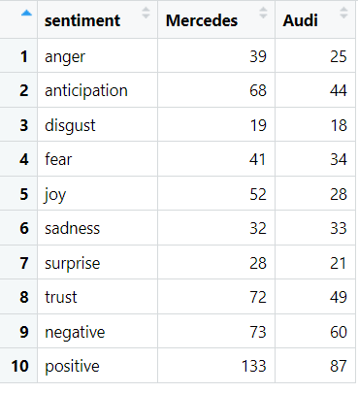

The highest emotion for Mercedes is Trust

The lowest emotion for Mercedes is Disgust

The highest emotion for Audi is Trust

The lowest emotion for Audi is Disgust

1. Create a word cloud represents which term is having highest frequency

The word cloud here it is able to print ascending which it will start from low frequency to high frequency.

So, you are able to see the size difference in words.

The below table will represent highest frequency.

Mercedes Frequency

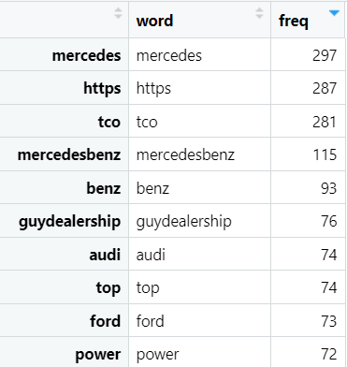

Audi Frequency

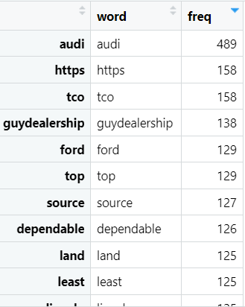

Word cloud for Mercedes

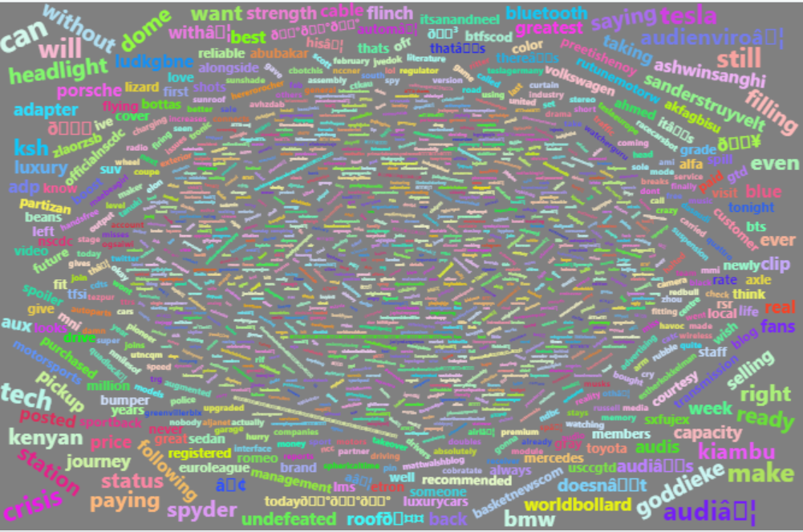

Word cloud for Audi

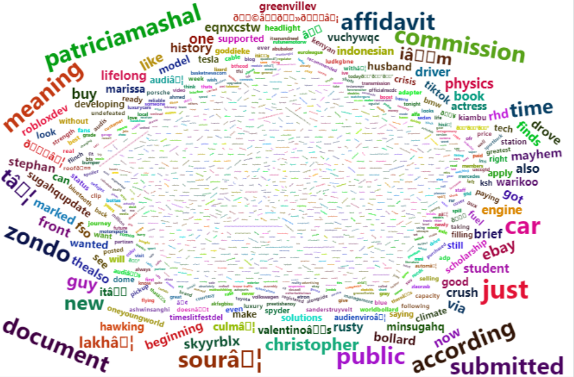

1. Find whether the feedback is positive or negative.

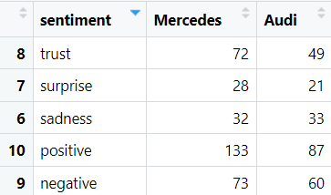

For both of Mercedes and Audi have positive feedback.

1. Create a visualization for above scenerios.

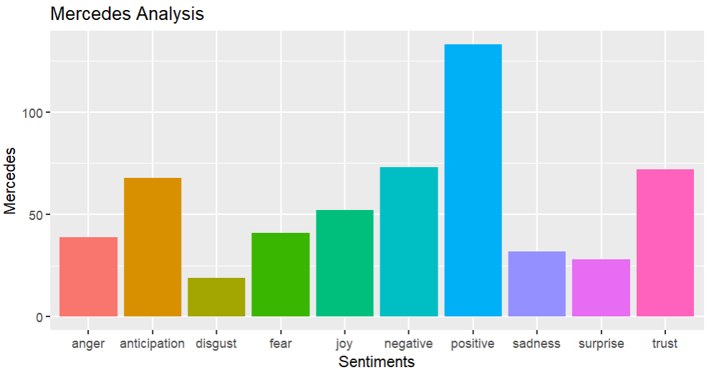

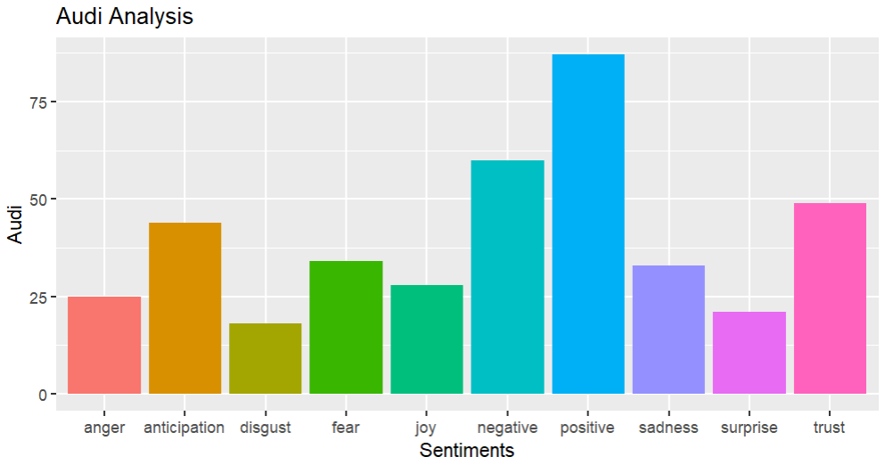

1. Analyse the data and mention 3-4 points to conclude the complete analysis.

1] The people are mostly given the positive feedback for both Mercedes and Audi.

2] As compare to other emotion, trust was high. It may arrive because of service given by both the companies.

3]The low emotion was disgust.

4]the companies are competing each other wisely. Sometimes they are differing themselves with price and their marketing strategies.

5] Most of discussion was between competing companies like ford. The people are comparing automobiles with other companies.